Use Case Diagram (Manager)
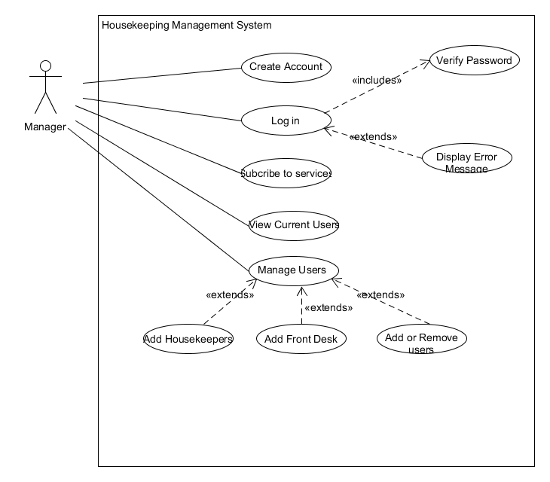
Manager interaction with the housekeeping application, the manager firstly needs to create and account and log in and subscribe to the services in order to use the application.

Activity Diagram (Manager)
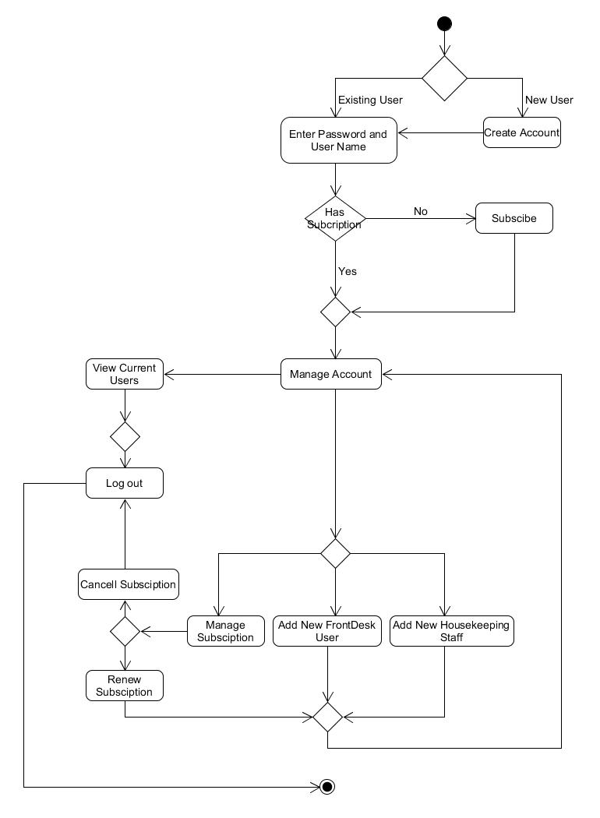

Activity Diagram steps (Manager)
1 | If the manager is a new user then they need to create a account
2 | IF Manager is an existing they need to first log in to the system
3 | IF the manager doesn’t have subscription the manger need to subscribe to the services
4 | IF the manger has a subscription then the manager can add or remove users
5 | View existing users
6 | Manage Subscription
7 | Add new front desk staff
8 | Add New Housekeeping Staff
9 | Renew or cancel subscription
10 | Log out

System Function of Manager
Activity | Input | Process | Output | User
Creating Account | - User Name  - Password  - Email | Add Username and password, Email to database | Send Email to confirm user | User gets confirmation via email of the account
Subscribe to service | - Name of accommodation  - Number of rooms  - Enter payment option | Add to users database and reconfirm user input | Send email to confirm payment | Manager can add users (Front desk , Housekeepers)
Add Housekeepers | - First and last name  - Contact details  - Allocate ID and password | Add to database the user name and ID | Display user details and position | Housekeeper Staff can log in to the interface
Add Front desk | - First and last name  - Contact details  - Allocate ID and password | Allocate information to database with user name, ID and position | Display user Details and position | Front desk can view housekeepers and rooms in the accommodation
Renewal or cancellation of Service | - Login With user name and password | Select manage account and select renew or cancel service | Either cancel services with take you to main screen,  Renew will take you to main screen. | Manager will get an email confirming the changes (Renewal or Cancellation)

Use Case Diagram (Administrator)
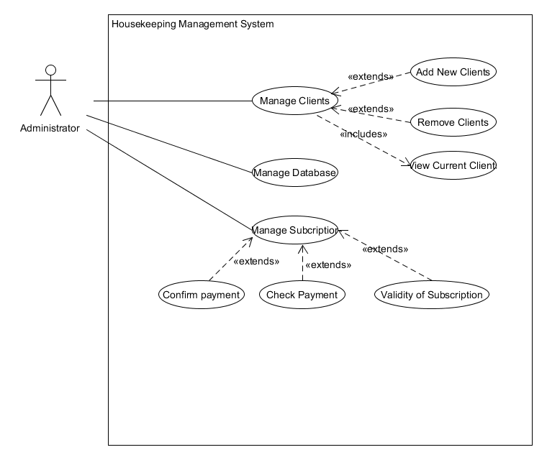
Administrations interaction with the housekeeping application is to ensure that all subscribed clients and their information is kept safe and also to add new clients on to the services provided by us.

Activity Diagram (Administrator)
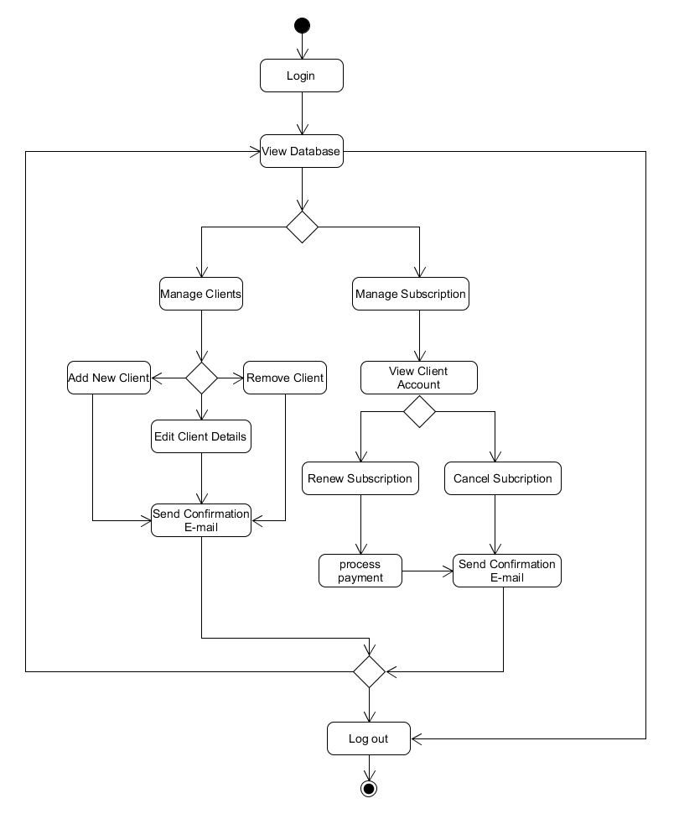

Activity Diagram steps (Manager)
1 | Administrator needs to log in to the portal
2 | View Database
3 | Manage Clients
3.1 | Add new Clients
3.2 | Edit Client Details
3.3 | Delete Client Details
4 | Send Email Confirmation of Changes
5 | View Database
6 | Manage Subscription
7 | View Client Details
8 | Renew Subscription
8.1 | Process Payment
9 | Send Email confirmation
10 | If cancel subscription
11 | Send email to client of the changes
12 | View Database or log out

System Function of Manager
Activity | Input | Process | Output | User
Log in | - User Name  - Password | Enter Username and password | Administrator logged in | Admin can view database
Add new Clients | - Name of accommodation  - Name of client  - Contact details  - Email ID | Add to users database and reconfirm user input | Send email to confirm | Admin can either log out or move to manage Subscription
View Client Account | - Enter Client name  - Enter Clients Accommodation ID | Find on data base | Display Clients Account | Admin can cancel subscription or renew
Renew subscription | - On clients account process payment and allocate payment to account | Save Input to database | Send email confirming payment | Client receives receipt of payment
Cancellation of Service | - Clients requests cancellation of service | Select account and select cancel service | Cancel services confirmation email. | Client will receive email of cancellation.

